**Unveiling the Struggle:**

**A Photographic Essay on Access to Education in African Communities**

**Introduction**

Access to quality education remains a significant challenge in many parts of the African continent, impacting millions of lives and hindering progress. This photographic essay aims to illuminate the complexities and disparities surrounding education within African communities.

1. **Portraits of Aspiration:**

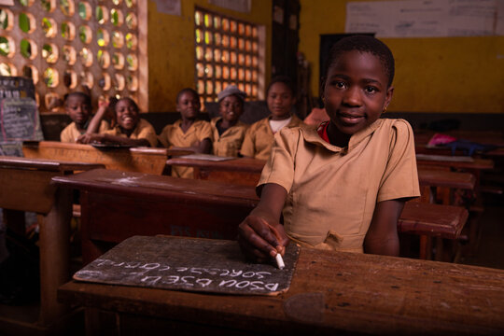 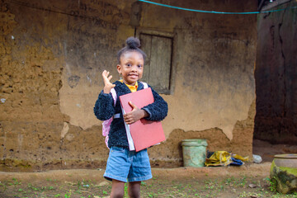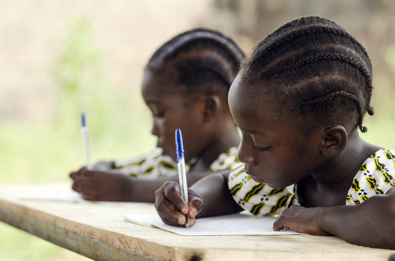

This series of portraits captures the dreams and aspirations of children from diverse African communities. They show their eagerness to learn, their bright smiles, and the hope shining in their eyes despite the challenges they face.

1. **Educational Barriers:**

This highlights some of the obstacles faced by these children and their communities in accessing education. The images depict long distances travelled to reach schools, overcrowded classrooms, lack of adequate resources such as textbooks and facilities, and the impact of poverty on learning.

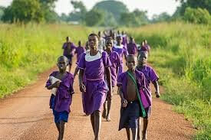 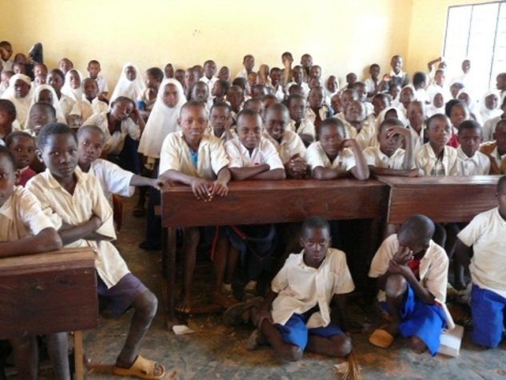

1. **Triumphs Amidst Adversity:**

Here we highlight stories of resilience and determination. The images show innovative educational initiatives within the communities - community-run schools, passionate teachers, and local programs striving to fill the educational gaps.

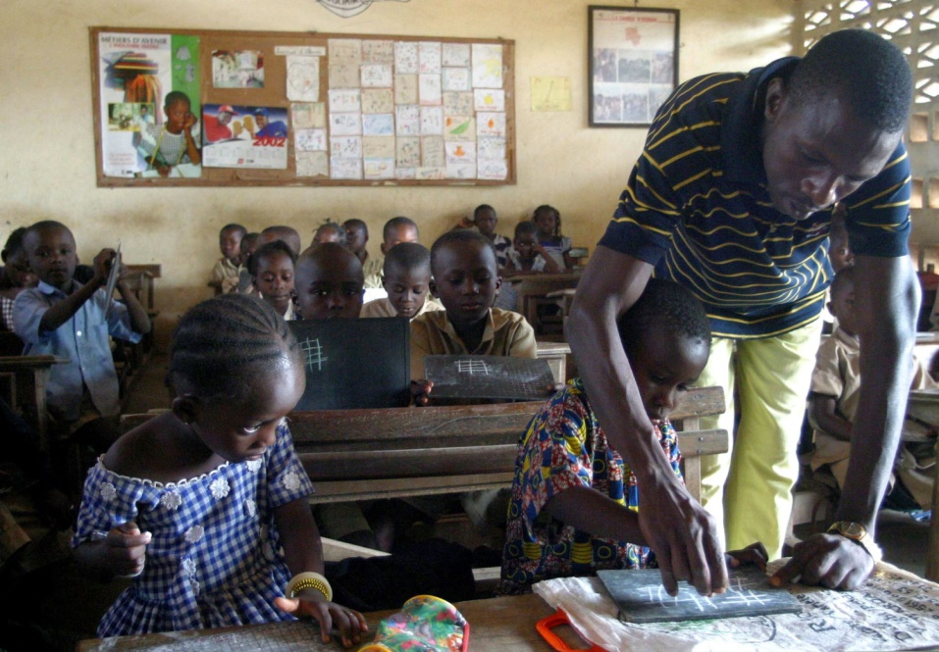

1. **Gender Disparities:**

The image showcases the struggles faced by girls in accessing education due to cultural norms, early marriage, early pregnancies or lack of facilities. The second image is of empowered girls breaking barriers and pursuing education against the odds unlike the ones facing the challenges.

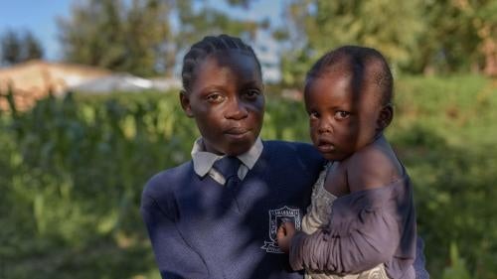

1. **The Role of Community:**

The importance of community involvement in supporting education is shown here. It captures images of community leaders, parents, and volunteers actively participating in educational initiatives, emphasizing the collaborative effort required for change.

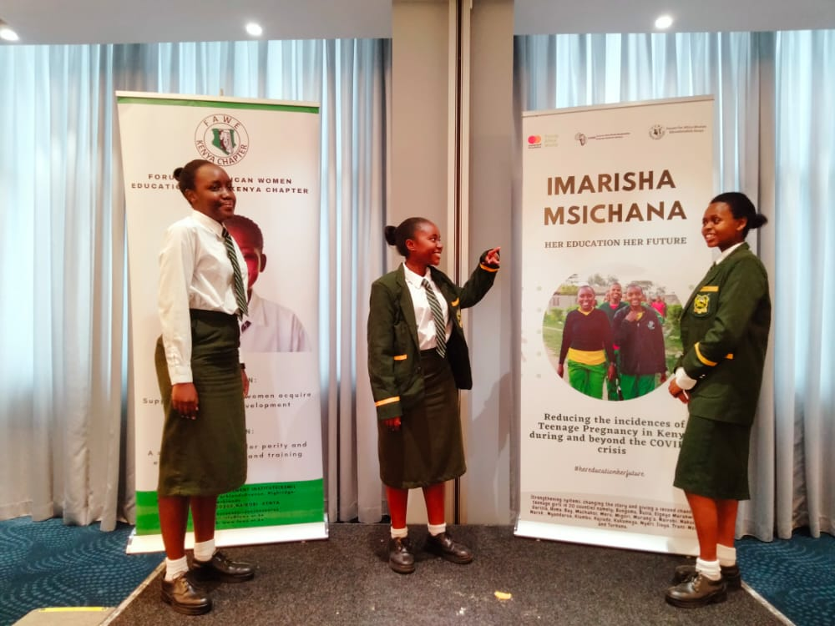

1. **Hope for the Future:**

Despite the challenges faced the images portray hope and progress. Success stories of individuals who have overcome educational barriers and are making a positive impact in their communities through their education are shown.

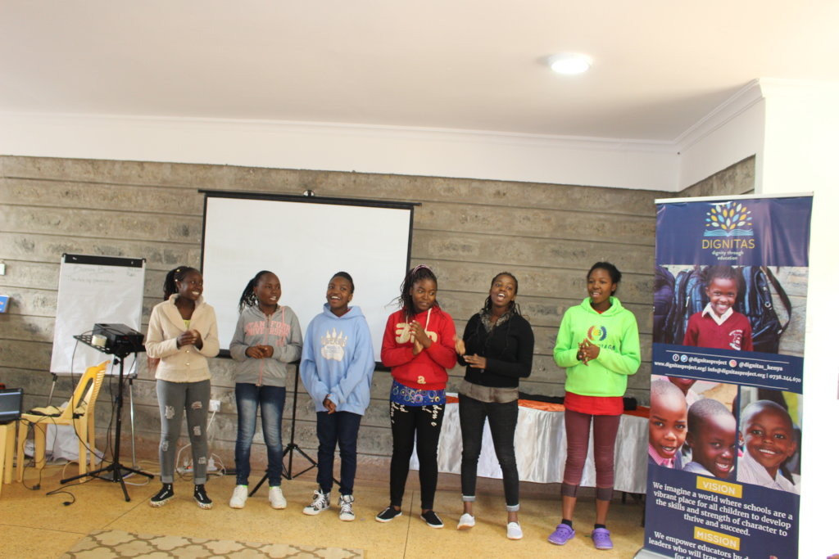

**Accompanying Text:**

Include short, impactful narratives or captions accompanying each set of images. These captions should provide context, stories, statistics, and insights into the challenges faced, the resilience displayed, and the steps being taken towards improving education in these communities.

**Conclusion:**

In summary, a call to action, urging viewers to support initiatives or organizations working towards improving access to education in African communities can help curb this challenge. Such as;

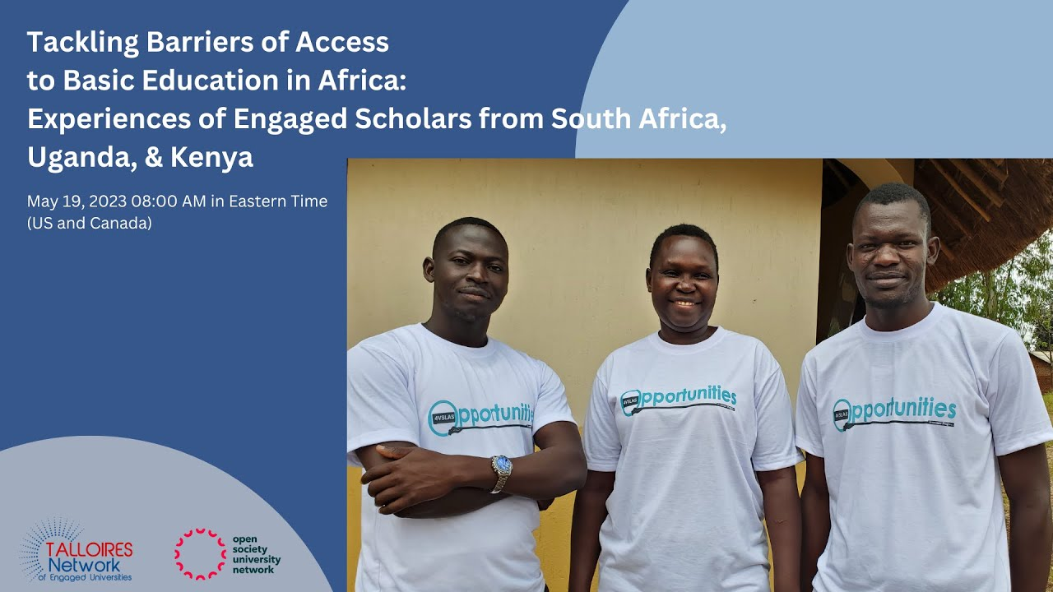

The images aim to provoke empathy, raise awareness, and inspire action towards a more equitable and accessible education for all in African communities.